*Passage d’un modèle conceptuel de données(MCD) au modèle relationnel(MRD)*

*1/Le Modèle conceptuel :*

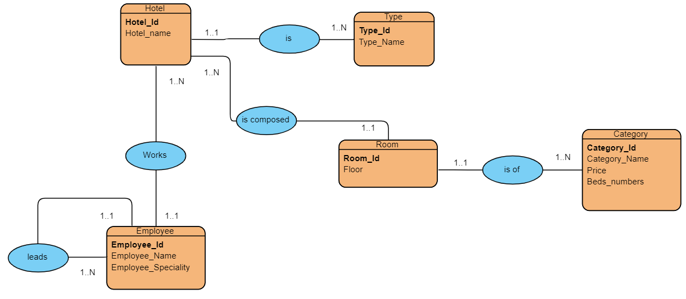

*2/ Le Modèle Relationnel :*

*Hotel (****Hotel_Id****, Hotel_name,* ***#Type_Id****)*

*Type (****Type_Id****, Type_name)*

*Employee (****Employee_Id****,Employee_Name, Employee_Speciality,* ***#Hotel_Id****)*

*Hotel (****Hotel_Id****, Hotel_name)*

*Employee (****Employee_Id****, Employee_Name, Employee_Speciality,* ***#director_Id****)*

*Room (****Room_Id****, Floor****, #Hotel_ Id****)*

*Hotel (****Hotel_ Id****, Hotel_name)*

*Room (****Room_Id****, Floor,* ***#Category_ Id****)*

*Category (****Category_ Id****, Category_Name ,Price,Beds_Numbers)*